**Intervals**

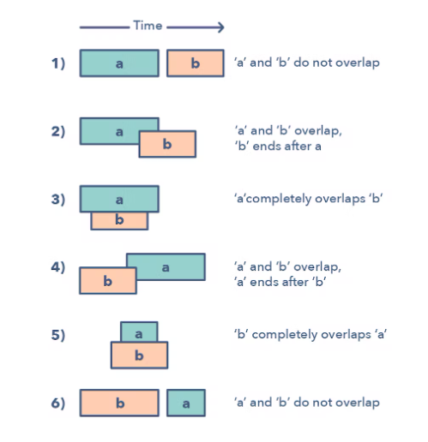

**Ways to Identify the pattern:**

* If you’re asked to produce a list with only mutually exclusive intervals
* If you hear the term “overlapping intervals”.

**Common problems you use the sliding window pattern with:**

* Intervals Intersection (medium)
* Maximum CPU Load (hard)

**Broad Categories:**

* Merging intervals with result (Merge Intervals, Insert intervals)
* Result independently generated (Interval intersection)
* Use of Heap to find the result (Meeting Rooms, Max CPU Load time, Conflicting Appointments)

**Strategies to Solve the Problem:**

* Understand the six cases shown in the figure of different scenarios and make the criterion of overlapping very clear.
* Try to see if heap can be involved to find the efficient solution.